Building guidance

Arvinte Razvan

**Content**

1. Introduction
   1. Summary
   2. Motivation
2. Application flow
   1. Image processing
   2. Android follow-up
3. Use cases
   1. Student
   2. Firefighter
   3. General Admin
4. Personal Contributions
   1. Application Contribution
   2. Extra Research and Conclusions from them.
5. Conclusions
6. Bibliography
7. Introduction
   1. Summary

This thesis represents an application that is design to locate different classes in UAIC campus and guide the user to the desired location within the faculties.

It also provide geographic support with the help of the Google Maps API and Google Location API.

* 1. Motivation

One of the problems that this application wants to solve is the lack of space awareness that fresh students usually have. Many fresh students don’t know the location of the classes that they have to attend and this application is designed to be simple to use and user-friendly.

Also in case of emergencies the fire fighters can use this application to quickly locate the problem by using the buildings plans provided instead of trying to get them by other means which can take precious time.

1. Application flow

Application flow CPU -> Phone

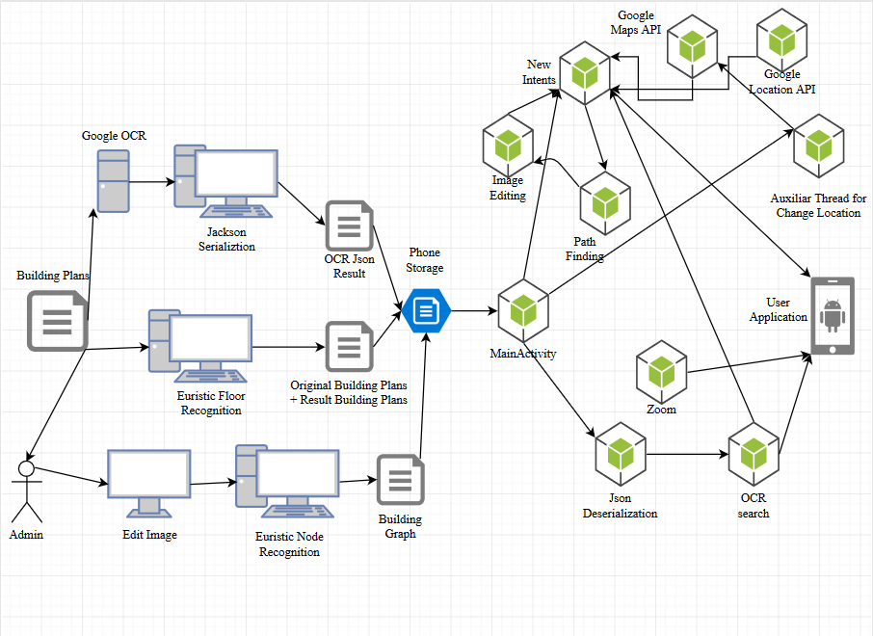

* 1. Image processing

Parsing Floor Plan Images.

-neuronal networks-

One important article in this direction is an article written by Samuel Dodge, Jiu Xu and Bj ̈orn Stenger. This article is meant to make a summary of a big set of algorithms and neuronal networks, proving their efficiency on test datas.

In their thesis they combine three methods to extract geometric and semantic information: Wall segmentation, object detection, and optical character recognition (OCR).

Those three are the key factors into recognizing and classifying the floor image.

**Wall segmentation**

They use fully convolutional networks ( FCN ) for segmenting wall pixels. They train models with different pixel-stride value and compare FCN architectures for different final stride layers to find the best stride value. Starting with a FCN-32s with a 32-pixel stride, initialized with ( Visual Geometry Group )VGG-16 parameters , in sequential training each model is initialized with the parameters of the previous one. All models are trained by stochastic gradient descent with momentum and a batch size of 1.

**Object detection**

They use ( Convolutional Neuronal Network ) R-CNN for object detection and recognition. By doing so they can detect objects like: doors, sliding doors, stoves, bath tubs, toilets and sinks.

**Optical Character Recognition**

They used Google Vision API for detecting and recognizing text in their images. This proved useful since in this way they can make use of many more languages then just English.

**The flow of their algorithms for floor image recognition.**

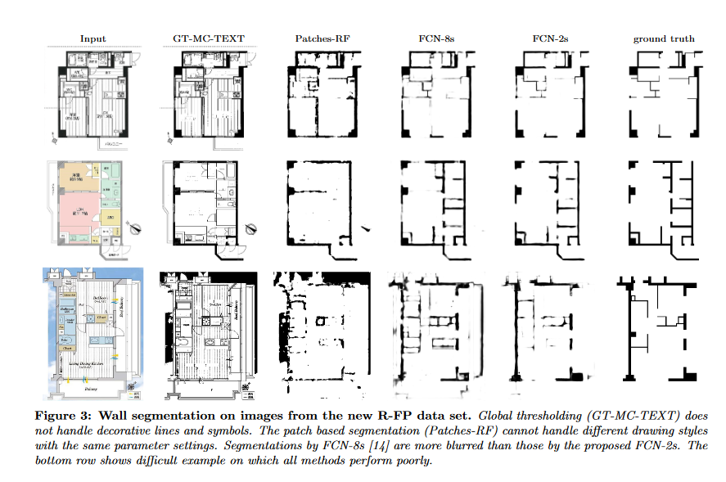

The image above is a screenshot of a scheme from their article.

(6.1 Bibliography)

**Their conclusion**

“We show that an FCN with stride of 2 achieves better performance than a stride of 8. The smaller stride is effective because some walls can be easily described by low level features. The FCN model combines features from subsequent layers that describe contextual information and texture information with these low level features. Secondly, the smaller stride allows us to predict more precise wall locations. Walls are often very thin structures that cannot be precisely predicted at larger strides.

From the floor plan we extract a parsed representation of wall locations, objects, and size information.”

**Personal Conclusion**

This article is very useful and acurate at detecting floor plans, but the main problem of this solution is that they use and train neuronal networks. In the context of android development, the computational power if a big problem since it would have a big system resource requirement and a problem with the power consuming.

**Use case**: Accuracy very good but performance lacks time-wise. The memory used is not a problem for a high specifications android device.

This being said, I decided that I should inspire myself from their solution and try to find a faster and simpler one, suited for android development.

Computer process

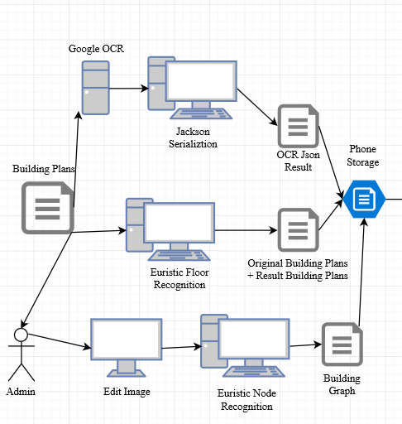

Parsing Floor Plan Images.

-euristic solution, personal solution-

The solution chosen is an euristic one, based on the generic propriety of the building wall. That propriety is that the wall is represented by of the biggest groups of adjunct points that are black.

Starting from an auxiliar matrix with the size of the picture and marking groups of black pixels with identifiers, we can later select the largest group of black pixels using a fill algorithm similar to the Lee Algorithm. The Lee Algorithm takes all the non-visited neighbours and add them to a queue. By doing so we can visit all the black pixels of a group.

Having selected this groups of black pixels we remove all other pixels from the image, creating a new simple image.

Code that is selecting only the black pixels.

|  |
| --- |
| image = ImageIO.*read*(inPath);  int bin=80;  for(int i=0;i<image.getWidth();i++)  for(int j=0;j<image.getHeight();j++)  {  try {  int k=image.getRGB(i, j);  int b = 0xFF & (k);  int g = 0xFF & (k>>8);  int r = 0xFF & (k>>16);  int a = 0xFF & (k>>24);  if((b>bin|r>bin|g>bin))  k=0xFFFFFF;  else  {  k=0;  }  image.setRGB(i, j, k);  }  catch(Exception error)  {  *out*.println(Integer.*toString*(i) + " "+ Integer.*toString*(j));  }  } |

Code that is creating the groups of black pixels:

|  |
| --- |
| int aux[][]=new int[image.getWidth()][];  for(int i=0;i<image.getWidth();i++)  {  aux[i]=new int[image.getHeight()];  for(int j=0;j<image.getHeight();j++)  aux[i][j]=0;  }  int number=1;  ArrayList<Long> strength=new ArrayList<Long>();  for(int i=0;i<image.getWidth();i++)  {  for(int j=0;j<image.getHeight();j++)  {  int k=image.getRGB(i, j);  k=0xFFFFFF&k;  //EE1E27  if(k==0&&aux[i][j]==0)  {  strength.add(*fill*(i,j,number,aux,image));  number++;  }  }  } |

Code that is selecting the largest group of black pixels:

|  |
| --- |
| number=0;  long val=0;  for(int i=0;i<strength.size();i++)  {  if(val<strength.get(i))  {  val=strength.get(i);  number=i;  }  }  number+=1;//array starts from 0 but the numbering started with 1  strength.sort(null);  for(int i=0;i<image.getWidth();i++)  for(int j=0;j<image.getHeight();j++)  {  if((image.getRGB(i, j)&0xFFFFFF)==0&&aux[i][j]!=number)  image.setRGB(i, j, 0xFFFFFF);  } |

And now the result is that this new image represents the walls of the floor plan image.

Initial Image, Building C Second Floor, UAIC

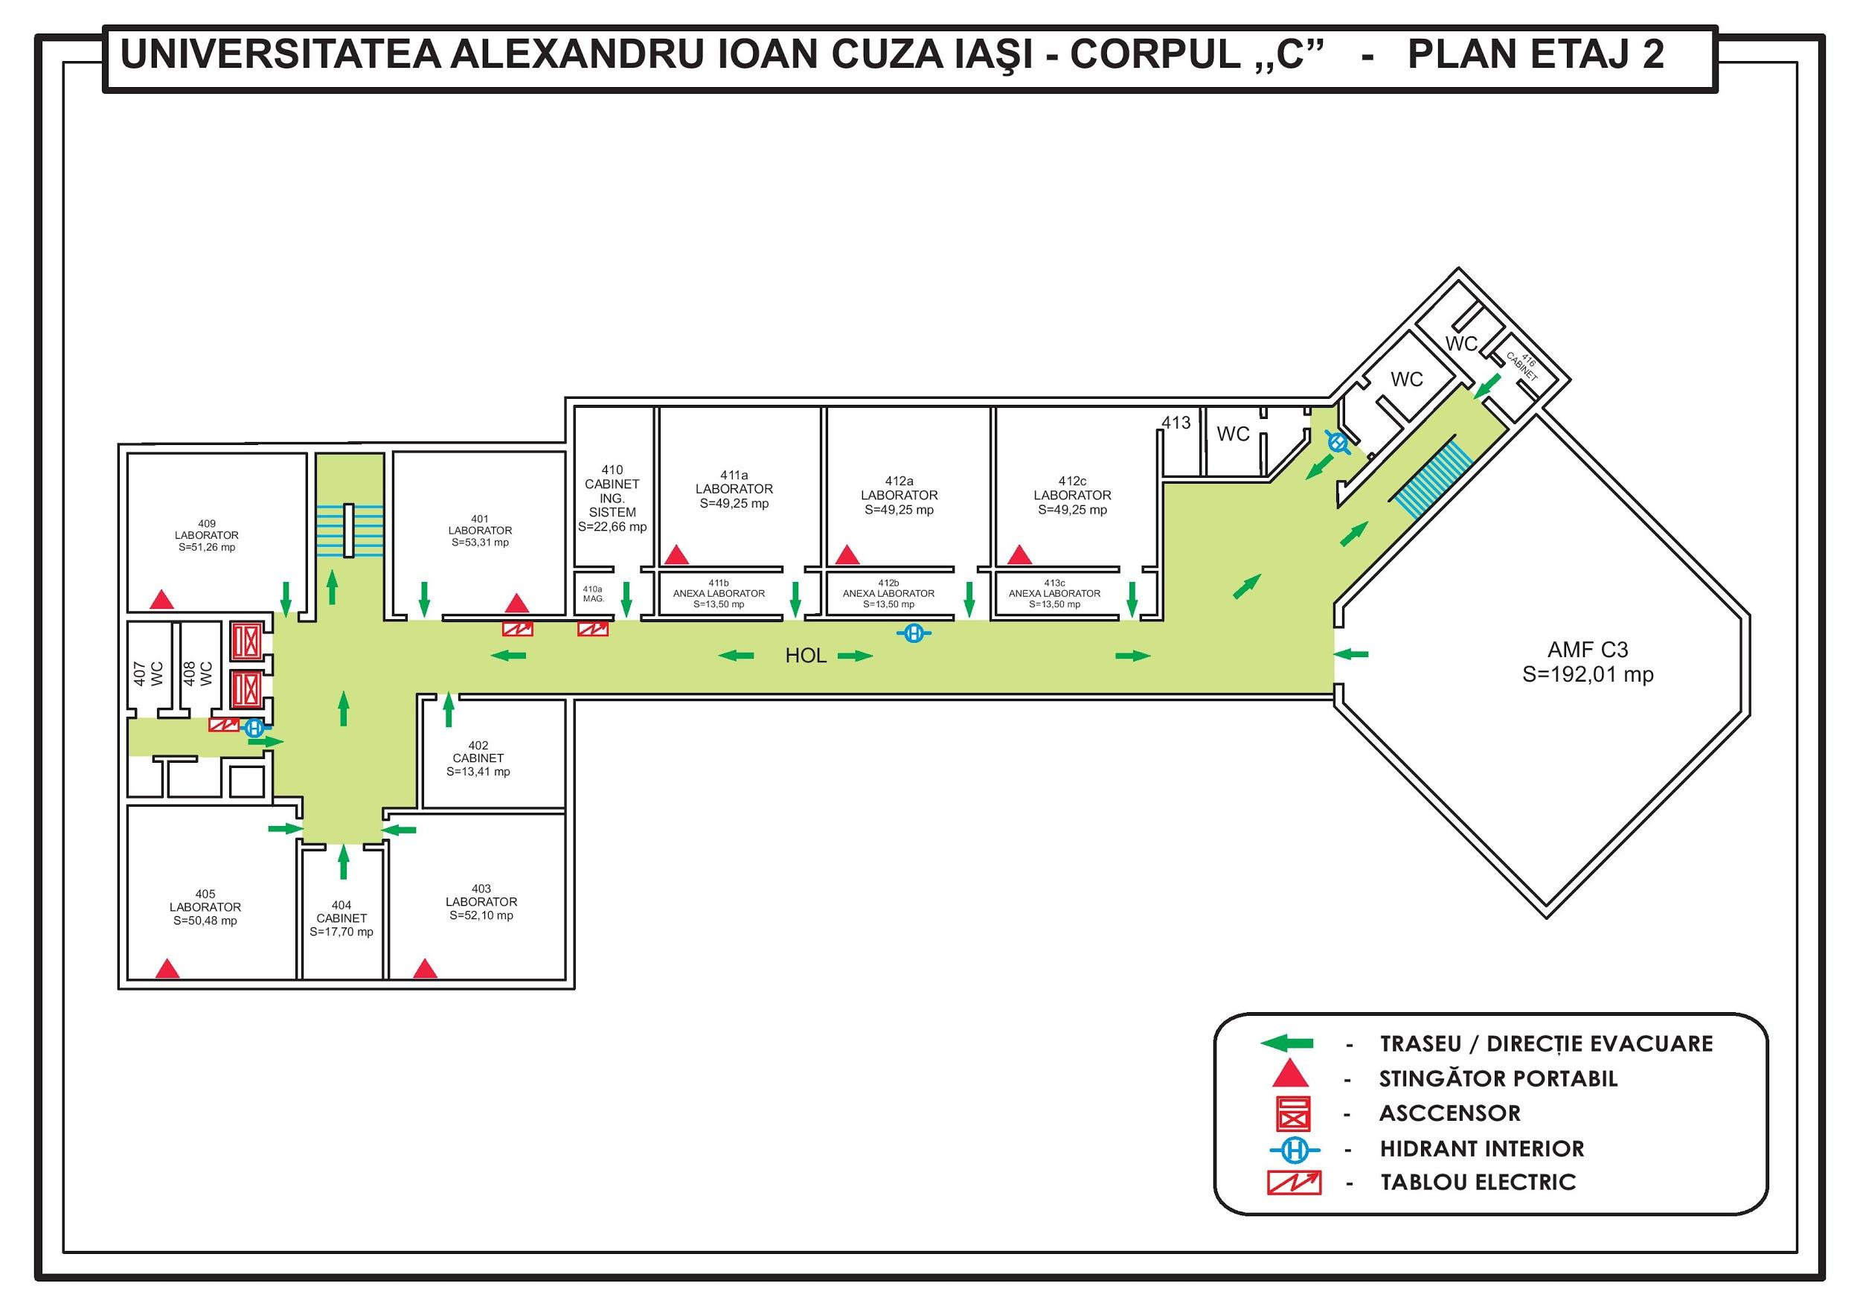

Taken from Building C Plans, UAIC

Result Image, Building C, Second Floor, Uaic[1]

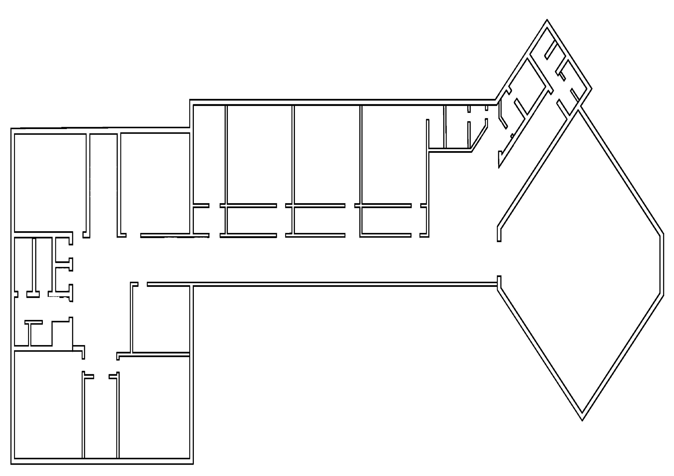

**Conclusion**

**Use case**: Accuracy can be a problem depending on the consistency or quality of the images. Uses little memory when running the euristic algorithm. Also it linear time in raport with the size of the image.

With this resulted image [1] above, the walls are extracted successfully and simple operations can be applied to the image like search algorithms.

On the other hand, the image[1] can be re-edited for a more common use later on ( since all the symbols can be considered a nuisance if not needed ).

OCR ( Optical Character Recognition )

For the OCR part was used the Google Cloud Vision API. The received data was stored into a custom class that later will be serialized with Jackson API for Json serialization. The reason the default class serialization was not used that when serializing the class instances, the package data is stored within the class so that later it will require the same package for deserialization. Taking the fact that we move the data from an java application on the computer to an android application on phone, the package serialization/deserialization becomes a problem.

Solution: Serialization in Json format using Jackson, hand-programmed deserialization for the OCR data on android. Also in the filename field is concatenated the floor and the building name of the specific room that was found.

|  |
| --- |
| floor_data_wrapper wrapper=new floor_data_wrapper(*all_floor_data*);  ObjectMapper mapper = new ObjectMapper();  mapper.writeValue(new File("c:\\work\\Licenta_2018_Arvinte_Razvan\\result_data\\Floor_data.json"), wrapper); |

Pathfinding-image recognition

Starting problem: taking in account the walls that have already been found in the images, there is still the problem with the stairs. Since the stairs don’t have a standard, a decision have to be taken for pathfinding to be possible.

Solution: Ask the admin to mark the stairs with a personal standard in the image so that later we can recognise them in the image. In the current case, it was chosen a purple circle. With this, calculating the center of the circle means finding the exact point from where the user can go up or down a level.

Considering different algorithms for pathfinding, one of the most precise is the Lee’s Algorithm. The method used by the algorithm is simply described in pseudocode as follows:

|  |
| --- |
| Initial_matrix = input_matrix  Queue.add( first_point )  While ( !Queue.isEmpty( ) )  current_point=Queue.pop( )  if ( current_point == end_point )  Print “ destination reached”  break  Queue.addAll( notVisitedYet( current_point.allNeighbours() ) )  Initial_matrix.mark( notVisitedYet( current_point.allNeighbours(),  Current_point.value+1 )  Initial_matrix.printPath( end_point, first_point ) |

The problem in our case with this algorithm is that he uses a lot of memory and computational time for big matrix. Some of the images we use contain tens of thousands of pixels.

Solution: transform the problem of pathfinding in a matrix into a pathfinding problem into a tree. With way fewer points to check, the problem becomes simple even for telephones.

So the admin will have to mark possible joints on the building plans and then make the connection between them.

Initial reduced picture

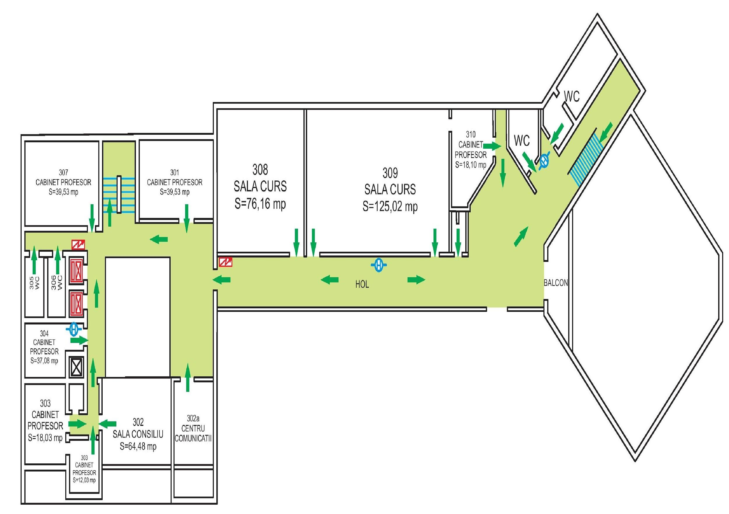

Modified by admin picture with joint points for stair and corners

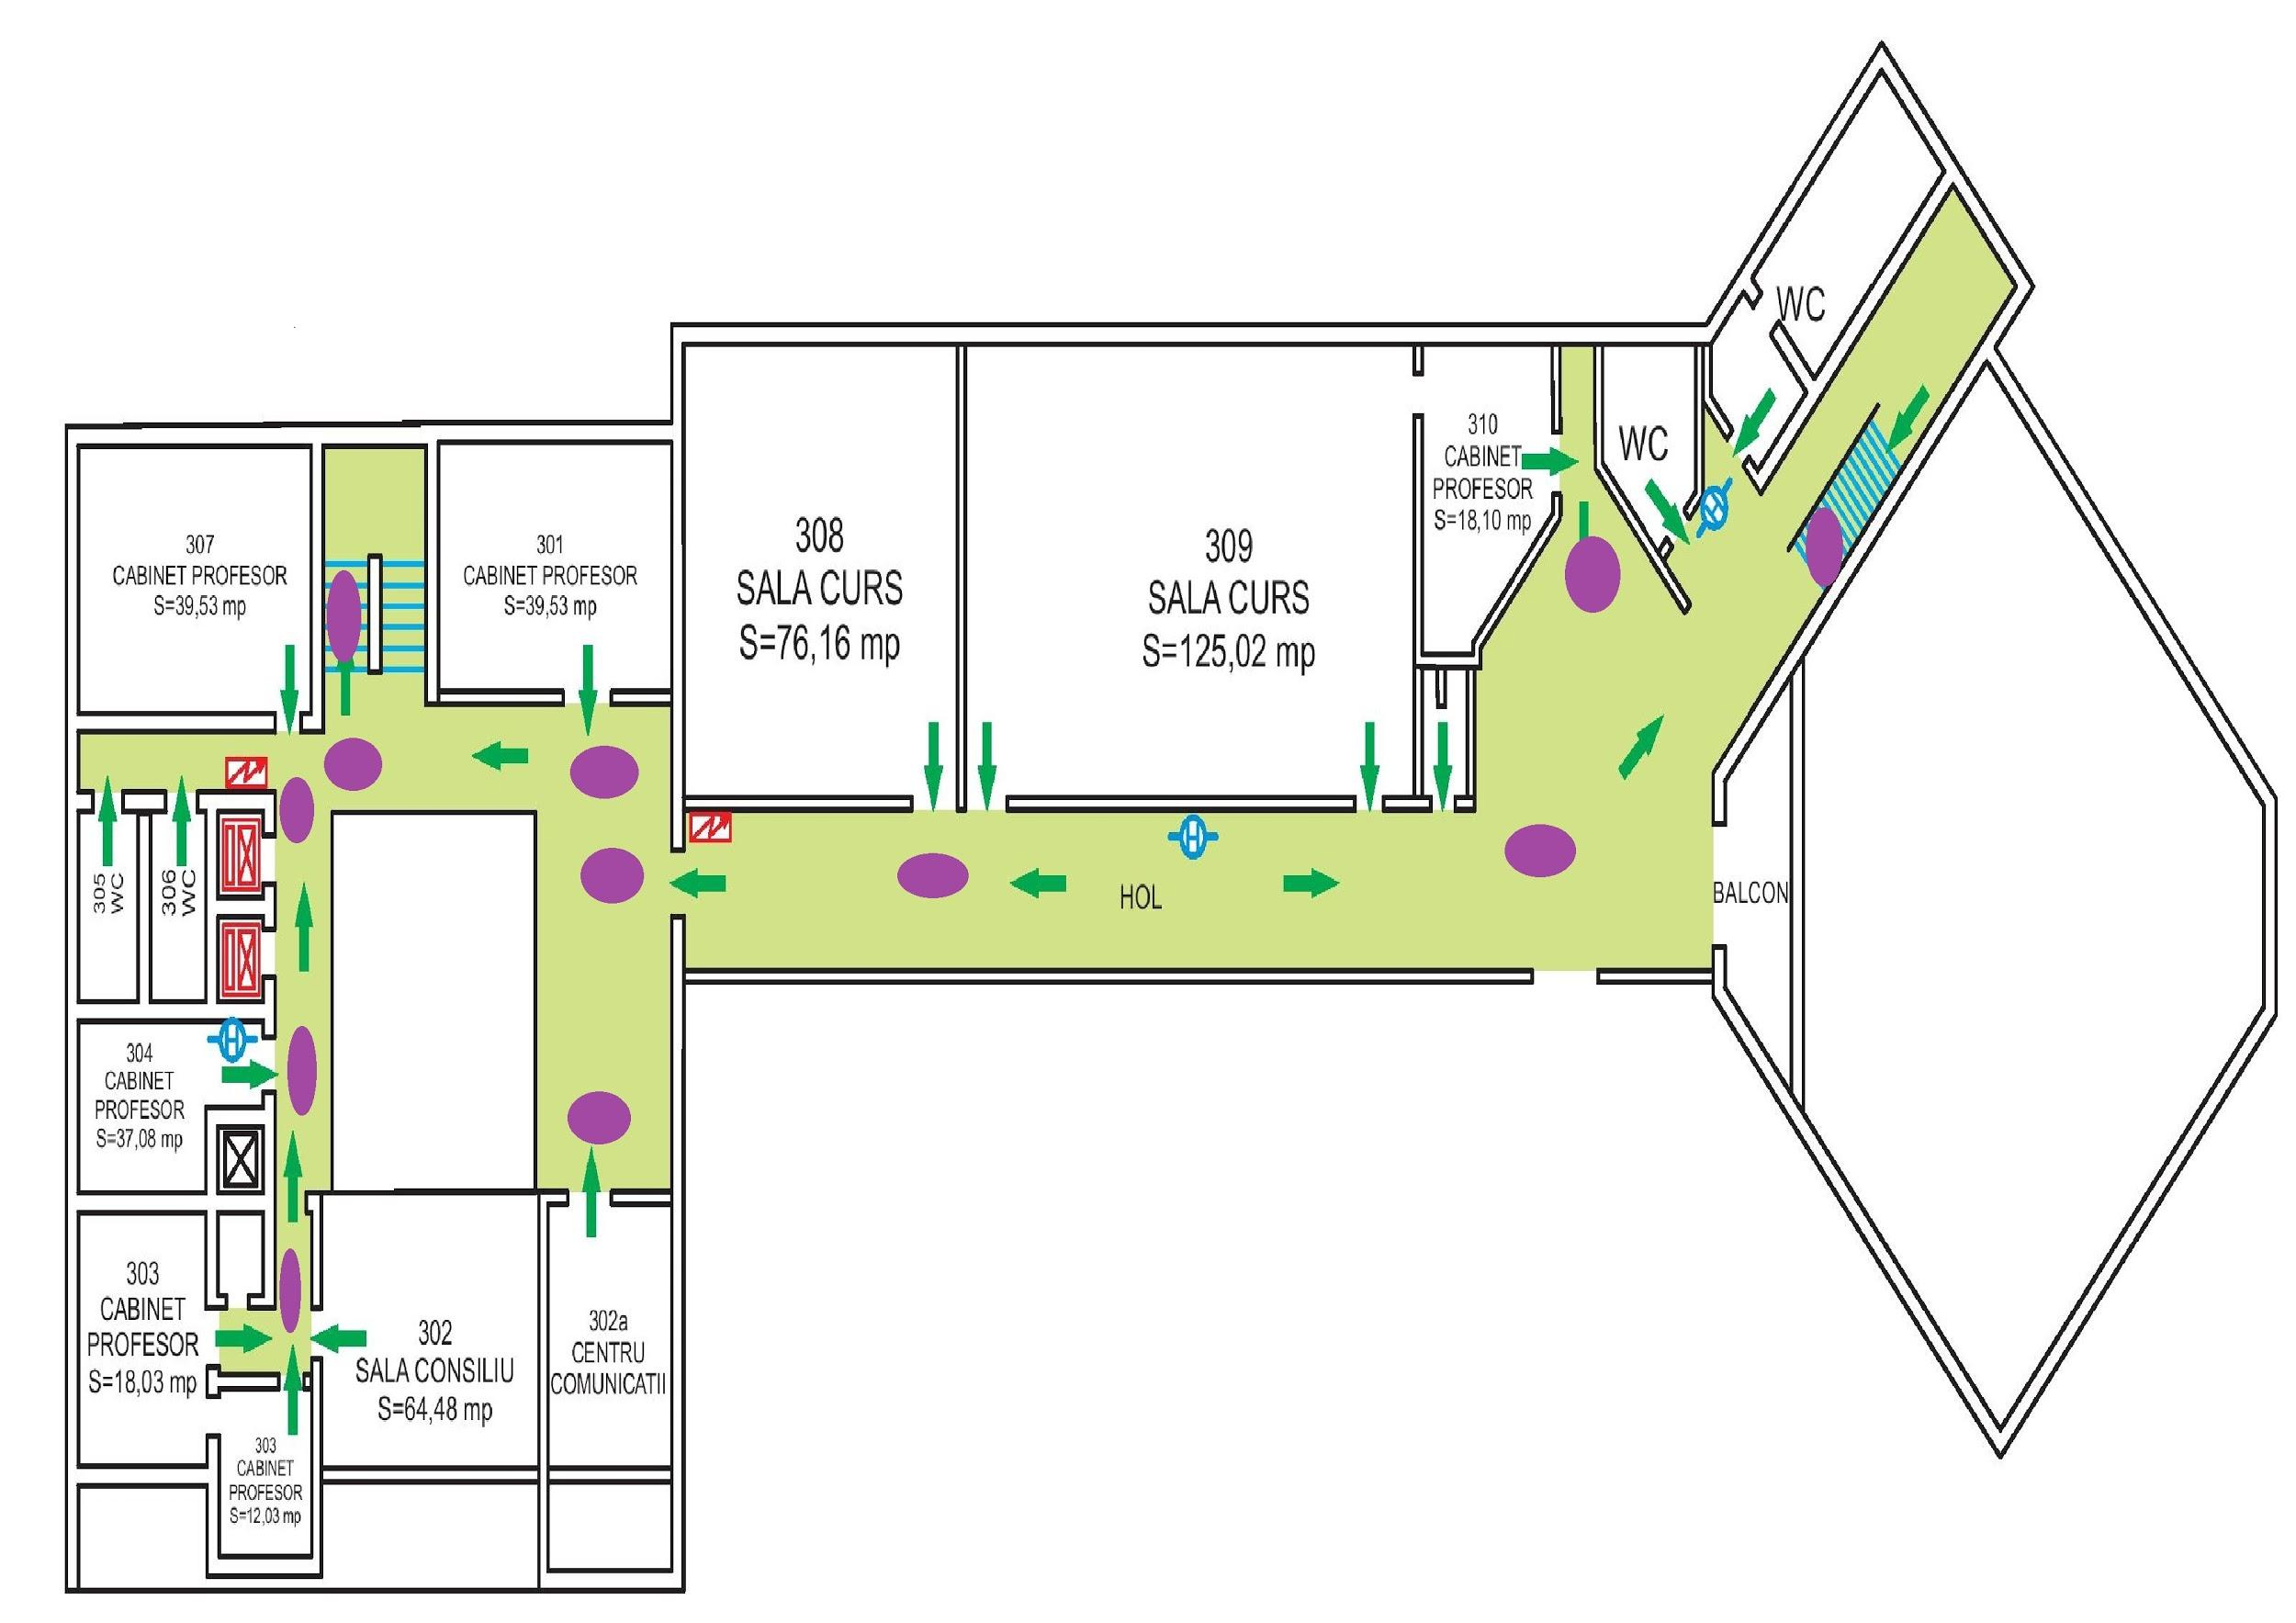

At this point there is no way for the administrator to understand how can the computer see the circles he drawn, so I implemented euristic image recognition algorithm for finding the circles and marking their centers with numbers, so that the admin can now make the connection between the joints.

|  |
| --- |
| static pair getCenter(int x,int y, int k, int[][] mat,BufferedImage img)  {  ArrayDeque<pair> coada = new ArrayDeque<pair>();  List<pair> points= new Vector<pair>();  coada.push(new pair(x,y));  pair current;  int strength=0;  while(!coada.isEmpty())  {  current = coada.pop();  points.add(current);  mat[current.x][current.y]=k;  strength++;  for(int i=-1;i<=1;i++)  for(int j=-1;j<=1;j++)  {  if(current.x+i>=img.getWidth()||current.y+j>=img.getHeight()||current.x+i<0||current.y+j<0)  continue;  if((img.getRGB(current.x+i, current.y+j)&0xFFFFFF)!=0xA349A3 || mat[current.x+i][current.y+j]!=0)  continue;  coada.push(new pair(current.x+i,current.y+j));  }  }  pair center=new pair(0,0);  for (int i=0; i<points.size();i++)  {  current=points.get(i);  center.x+=current.x;  center.y+=current.y;  }  center.x=center.x/points.size();  center.y=center.y/points.size();  if (points.size()<1000){  return new pair(0,0);  }  return center;  } |

The result of the joint-recognition algorithm

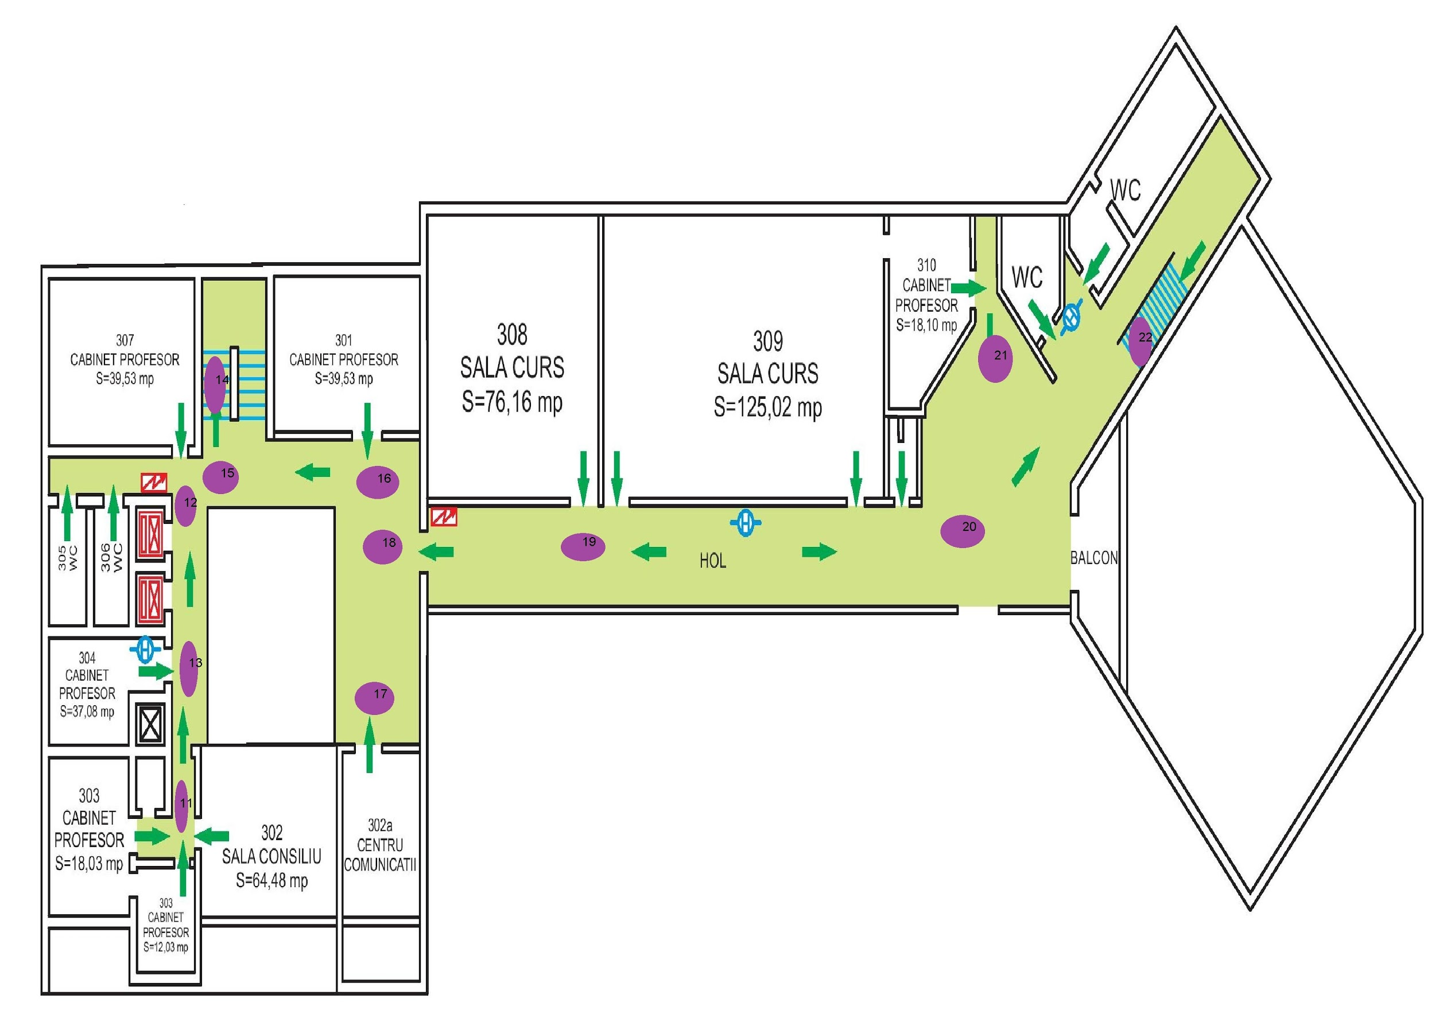

At this point the admin will fill up a list of edges between the points presented. He will also consider that there should be a connection between floors through the “stair” joints.

With this done, the next phase is serialize into a Json and send the data to the android device.

* 1. Android follow-up

On the Android side of the application flow, the phone will get the resources generated by the computer and use them to provide content to the user’s interactions in searching for a class, listing the building plans and listing possible suggestions in case of multiple choices.

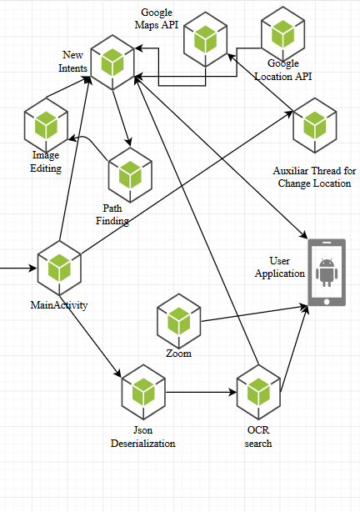

**Json Deserialization**

With the data generated from the computer , the android application has to deserialize the Json and to fill it’s own data structures that will be alter used in most of the application’s build interaction.

The classes that have to be deserialized.

|  |
| --- |
| **static class pair implements java.io.Serializable**  **{**  **public int x,y;**  **pair(int a,int b)**  **{**  **x=a;**  **y=b;**  **}**  **};**  **static class floor_data implements java.io.Serializable{**  **List<pair> centers;**  **List<String> words;**  **String fileName;**  **public floor_data(List<pair> centers, List<String> words, String fileName) {**  **this.centers = centers;**  **this.words = words;**  **this.fileName = fileName;**  **}**  **}**  **static List<floor_data> *all_floor_data*=new Vector<floor_data>();** |

The deserialization function that is used for the data that came from the computer:

|  |
| --- |
| public void Deserializare(){  JSONParser parser= new JSONParser();  try {  JSONObject myjson = (JSONObject) parser.parse(new FileReader("/storage/emulated/0/poze-root/result_data/Floor_data.json"));  JSONArray all_floors = (JSONArray) myjson.get("floors");  Iterator<JSONObject> itFloor = all_floors.iterator();  //parse all the floors  while(itFloor.hasNext()){  JSONObject current_floor= itFloor.next();  List<pair> Pairs=new Vector<pair>();  //parse the centers  JSONArray all_centers= (JSONArray) current_floor.get("centers");  Iterator<JSONObject> center= all_centers.iterator();  while(center.hasNext()){  JSONObject current_pair=center.next();  int x=((Long)current_pair.get("x")).intValue();  int y=((Long)current_pair.get("y")).intValue();  pair temp_pair = new pair(x,y);  Pairs.add(temp_pair);  }  //parse all words  JSONArray all_words = (JSONArray) current_floor.get("words");  Iterator<String> word= all_words.iterator();  List<String> Words=new Vector<String>();  while(word.hasNext()){  Words.add(word.next());  }  String filename=(String) current_floor.get("fileName");  System.*out*.println(filename);  floor_data temp_floor=new floor_data(Pairs,Words,filename);  *all_floor_data*.add(temp_floor);  }  }  catch (Exception e){  e.printStackTrace();  }  } |

**The OCR search** is composed of an adapter on a SearchView, the SearchView and the ListView for the items. This adapter filters the information and offers the user for each search result the specific building and floor of it.

**The filter function** for the searchView checks if the search is empty. In that case the view doesn’t change. But if the search is not empty the function will try to inflate the ListView asignated to the searchView results.

The filter function for the SearchView

|  |
| --- |
| public void filter(String charText) {  Log.*i*("Eu_search","filtering_text: " + charText );  if (charText.equals(""))  {  arrayRooms.clear();  arrayLocations.clear();  notifyDataSetChanged();  return;  }  charText = charText.toLowerCase(Locale.*getDefault*());  arrayRooms.clear();  arrayLocations.clear();  Log.*i*("Eu_search",room_list.toString());  int count;  for (count=0;count<room_list.size();count++) {  if (room_list.get(count).toLowerCase(Locale.*getDefault*()).contains(charText)) {  arrayRooms.add(room_list.get(count));  arrayLocations.add(filename_list.get(count).split("\\.")[0]);  count++;  //Log.i("Eu_search","Add in list: " + wp);  }  }  Log.*i*("Eu_search","Result"+room_list.toString());  notifyDataSetChanged();} |

The function that adds element to the View that will be inflated with search results.

|  |
| --- |
| public View getView(final int position, View view, ViewGroup parent) {  final ViewHolder holder;  if (view == null) {  holder = new ViewHolder();  view = inflater.inflate(R.layout.*list_view_items*, null);  // Locate the TextViews in listview_item.xml  holder.name = (TextView) view.findViewById(R.id.*name*);  holder.location = (TextView) view.findViewById(R.id.*location*);  view.setTag(holder);  } else {  holder = (ViewHolder) view.getTag();  }  // Set the results into TextViews  holder.name.setText(arrayRooms.get(position));  holder.location.setText(arrayLocations.get(position));  return view;  } |

**Google Maps API**

With the use of google maps, the application has a frangement that represents the map of the user’s city and some custom polygons that are link to the plan of the buildings. Those polygons are drawn by the admin.

Initialization of the map

|  |
| --- |
| private void initMap(){  if (CheckGps()) {  SupportMapFragment mapFragment = (SupportMapFragment)  getSupportFragmentManager().findFragmentById(R.id.*map*);  mapFragment.getMapAsync(this);  }  } |

This code draws the polygons that the user will work with. The user will use those polygons to open the plans of each building.

|  |
| --- |
| public void onMapReady(GoogleMap googleMap) {  polygons=new Vector<Polygon>();  mMap = googleMap;  final Polygon polygon_info = mMap.addPolygon(new PolygonOptions()  .clickable(true)  .add(  new LatLng(47.173919, 27.574654),  new LatLng(47.173968, 27.574802),  new LatLng(47.173876, 27.574885),  new LatLng(47.173821, 27.574733)));  polygon_info.setFillColor(ContextCompat.*getColor*(this, R.color.*argb_black*));  polygon_info.setStrokeColor(ContextCompat.*getColor*(this, R.color.*argb_black*));  polygons.add(polygon_info);  mMap.setOnPolygonClickListener(new GoogleMap.OnPolygonClickListener() {  @Override  public void onPolygonClick(Polygon polygon) {  if (polygon.equals(polygon_corp_D)){  Intent i = new Intent(getBaseContext(), Inside.class);  i.putExtra("corp","Corp_D");  startActivity(i);  }  if (polygon.equals(polygon_info)){  Intent i = new Intent(getBaseContext(), Inside.class);  i.putExtra("corp","Corp_C");  startActivity(i);  }  if (polygon.equals(polygon_feaa)){  Intent i = new Intent(getBaseContext(), Inside.class);  i.putExtra("corp","Corp_B");  startActivity(i);  }  if (polygon.equals(polygon_corp_A)){  Intent i = new Intent(getBaseContext(), Inside.class);  i.putExtra("corp","Corp_A");  startActivity(i);  }  }  }); |

**Google Location API**

With Google Location API, the application inserts markers and draws the shortest path to the destination from the current location of the user. Also while the application runs there is an auxiliar thread that keeps track of the user’s position and in case of a change in coordinates, the line will redrawn.

The code that will draw the first path on the map. On the moment the first path leads to Building C from UAIC.

|  |
| --- |
| if (mLocationPermissionsGranted) {  getDeviceLocation(new LatLng(47.173951, 27.574782));// will draw the first path, default Building C    if (ActivityCompat.*checkSelfPermission*(this, android.Manifest.permission.*ACCESS_FINE_LOCATION*)  != PackageManager.*PERMISSION_GRANTED* && ActivityCompat.*checkSelfPermission*(this,  android.Manifest.permission.*ACCESS_COARSE_LOCATION*) != PackageManager.*PERMISSION_GRANTED*) {  return;  }  mMap.setMyLocationEnabled(true);  mMap.getUiSettings().setMyLocationButtonEnabled(true);  } |

This is the function that is drawing a line from the current location to the selected destination.

|  |
| --- |
| private Polyline addPolyline(DirectionsResult results, GoogleMap mMap) {  List<LatLng> decodedPath = PolyUtil.*decode*(results.routes[0].overviewPolyline.getEncodedPath());  return mMap.addPolyline(new PolylineOptions().addAll(decodedPath));  } |

The function that is drawing the markers cam makes the user change his destination with OnMarkerClick. This way the user can choose the destination from the buildings marked on the map by the administrator.

|  |
| --- |
| private void addMarkersToMap(DirectionsResult results, GoogleMap mMap) {  Log.*i*("EU_Marked", String.*valueOf*(results));  mMap.addMarker(new MarkerOptions().position(new LatLng(47.174829,27.571814)).title("Corp_A"));//Building_A  mMap.addMarker(new MarkerOptions().position(new LatLng(47.175061,27.573703)).title("Corp_B"));//Building_B  mMap.addMarker(new MarkerOptions().position(new LatLng(47.173716,27.575032)).title("Corp_C"));//Building_C  mMap.addMarker(new MarkerOptions().position(new LatLng(47.172847,27.571887)).title("Corp_D"));//Building_D  mMap.setOnMarkerClickListener(new GoogleMap.OnMarkerClickListener() {  @Override  public boolean onMarkerClick(Marker marker) {  LatLng poz=marker.getPosition();  myLastPolyline.remove();  getDeviceLocation(poz);  moveCamera(poz, 15f);  return false;  }  });  } |

When trying to get the location from GPS, the application uses Google Location API which is getting the current location of the user. Also the application is using it’s current location to send a request to Google asking what is the shortest path between the current location and the destination that is currently selected on the map.

|  |
| --- |
| final Task myTask = mFusedLocationProviderClient.getLastLocation();  Task task = myTask.addOnCompleteListener(new OnCompleteListener() {  @Override  public void onComplete(@NonNull Task task) {  if (task.isSuccessful()) {  if (myTask.isSuccessful()) {  Location MyCurrentLocation = (Location) myTask.getResult();  DateTime now = new DateTime();  Double diff = *abs*(myCurrentOrigin[0].lat - MyCurrentLocation.getLatitude()) + *abs*(myCurrentOrigin[0].lng - MyCurrentLocation.getLongitude());  if (diff > 0.0001) {  myLine.remove();  myCurrentOrigin[0] = new com.google.maps.model.LatLng(MyCurrentLocation.getLatitude(), MyCurrentLocation.getLongitude());  DirectionsApiRequest Path = DirectionsApi.*newRequest*(getGeoContext());  Path.mode(TravelMode.*DRIVING*);  Path.origin(myOrigin);  Path.destination(myDestination);  Path.departureTime(now);  DirectionsResult result = null;  try {  result = Path.await();  } catch (ApiException | InterruptedException | IOException e) {  e.printStackTrace();  }  myLine = addPolyline(result, myGoogleMap);  }  }  }  }  }); |

Zoom

There is a class implemented that in case of any image displayed in the building plans are to be scaled so that the user can better view the image.

Pathfinding

The pathfinding on the android side has as input the graph parsed from the computer. This being said, the problems is finding the fastest route from one point to another in a graph.

The only problem is determining the start and finish points. This is solved by calculating for example the euclidean distance between the start_text and all the joints from that level, taking the closest node.

The algorithm used is a BFS( Breadth-first search ). This algorithm uses a queue to go through all the graph. It is similar with the Lee’s Algorithm described above, one of the differences being that here the algorithm works with more complex data structures that has neighbours in lists and not in north,south,east,west.

Having found the path, a function will start drawing the road to destination on copies of the current images of the building plans.

The following example starts has a path from room 310 first floor up to 410 second floor, from Faculty of Informatics UAIC.

First floor, Faculty of Informatics, UAIC

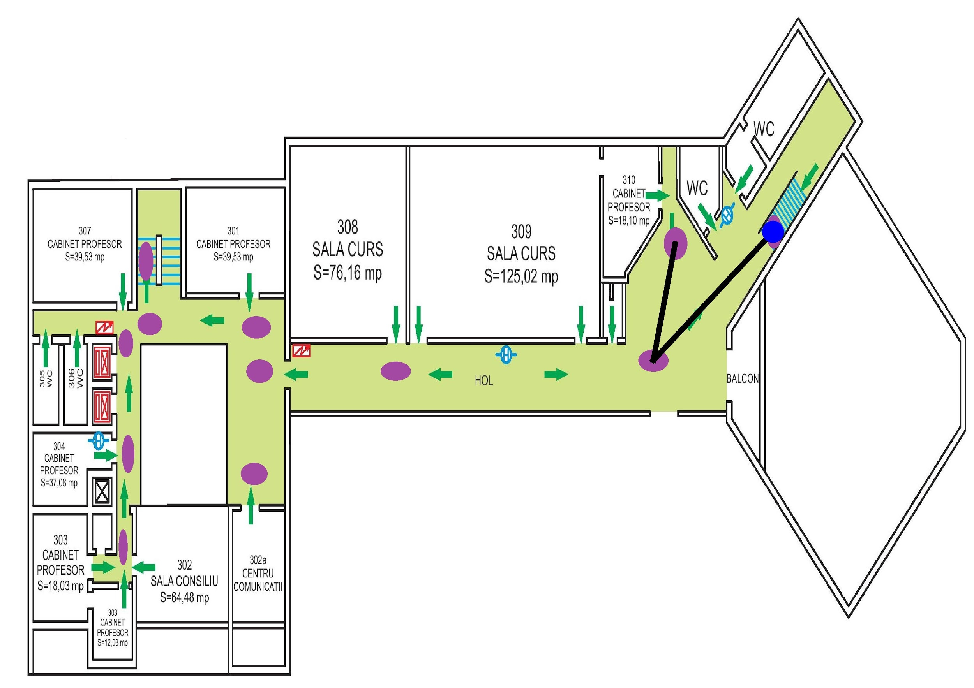

Second floor, Faculty of Informatics, UAIC

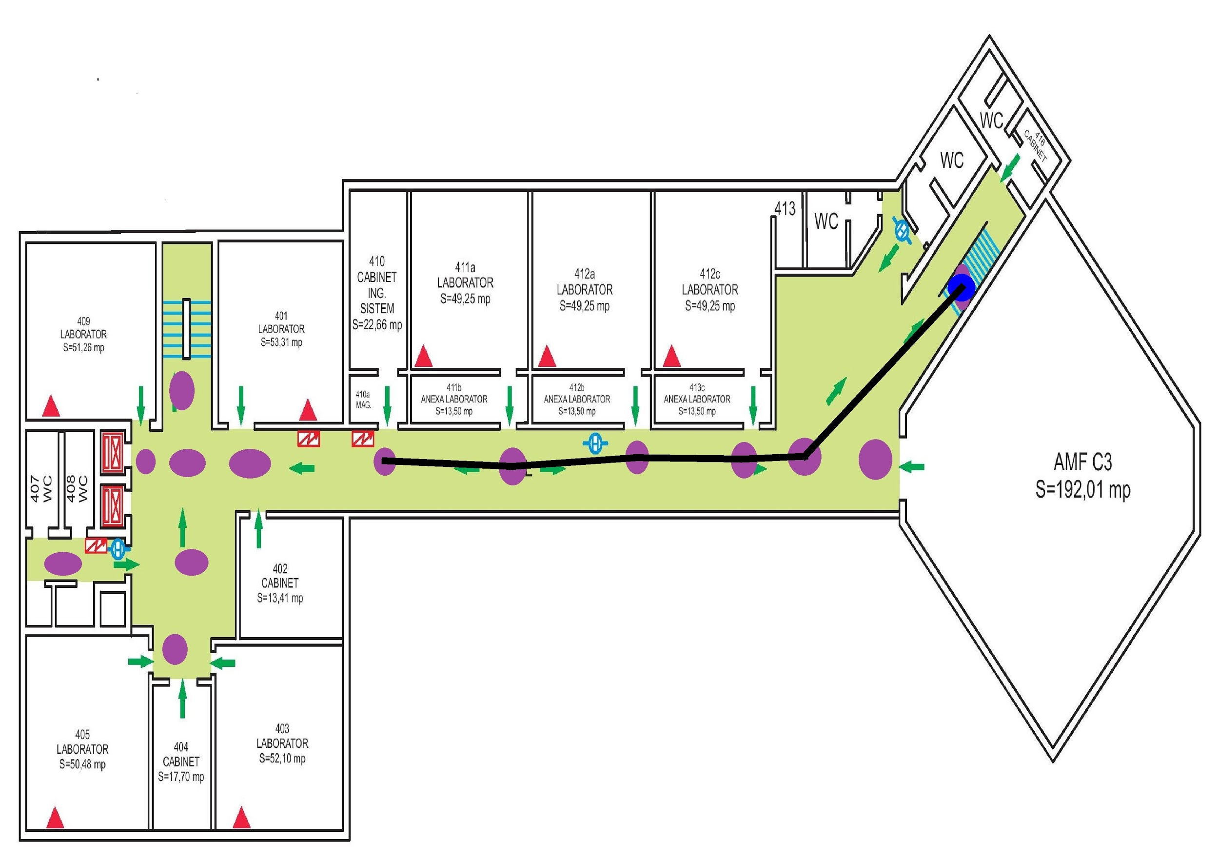

Those images are created and stored on the android device, the process of creating/editing images being the most costly action that the application will do resource-wise.

1. Use cases
   1. Student

In these days there is a lot of information on the internet and so many of the fresh student have problems with finding some of the basic information that they need in their studying at UAIC. One of the most important basic information is the location of the classes they need to attend. This application is meant to be simple to use and easy to understand. The application not only that it have a quick search which can guide the student to the place he wants to reach, but it also makes it easy for him to explore the campus from the app itself.

* 1. Firefighters

In case of emergency, there is almost no time to get information about the structure of the building in trouble. Getting the building plans from the administrators, having problems with busy telephone lines and having the victims unaware of their current position when a problem rises can provoke casualties that normally wouldn't be hurt. This application provides quick support with basic important information for both the possible victims of an incident and the possible forces of rescue.

The application simplicity proves very useful in such situation that can happen rarely.

* 1. General Admin

This application is not meant only for the UAIC campus. With basic configuration any administrator of a building that can provide it’s plans should be able to easily create a simple and useful application no matter how large or high the building is. The scalability of the application makes it usable for almost any type of building, fact that can help to a better safety in the current times.

1. Personal Contributions
   1. Short Introduction

This thesis can be developed very nicely with some ideas that i had on the way of solving the current needs that the article wants to solve. Unfortunately there were some problems with the development of these ideas that I researched, because of their complexity or the lack of accuracy.

* 1. Application contributions
     1. The application’s architecture

From the start I tried to be as efficient in time and memory when it comes to algorithms. I split the workload between computer and phone because usually the computer has better computational power then the phone. Also all the code was written in java so that it can work on both the android platform and the windows platform.

* + 1. My own serialization/deserialization

Although it is not as big of a feat as others, the class’s serialization / deserialization for cross-package/cross-platform in java has its own errors, most of them because of different package problem. My own deserialization was my “simple” solution to the problem.

Also it was interesting for me to have wrapper classes so i could properly serialize a vector of instances of other classes that also had a vector of instances of another class.

* + 1. My euristic Floor Image Processing

I realised that the known methods that were researched in Rakuten Institute of Technology from Arizona State University were very quite difficult to implement and also slow in both memory and time, so i created my own solution to the problem; a solution that is fast time-wise and uses very little memory, 2 * size( image ).

* + 1. The pathfinding

The architecture of the image pathfinding application flow is as follows: building plans, admin node editing, image node recognition, admin adding the edges, building the graph, serializing the graph (*) , on android deserialize, find the start and finish node, find the path with a BFS algorithm, edit image and finally create a new activity .

Until (*) all the modules are implemented for the computer in java, after (*) all the modules are implemented for the device in android.

* 1. Added research on the application
     1. Offline Tracking

Once you enter a building most likely the GPS signal will drop and the application won’t be able to guide you to the selected destination. For this problem the solution was Offline Tracking, where the application would use the phone sensors to calculate the distance that you went and in what direction or triangulate the wifi to find your location given the fact that the application already knows the positions of the wifi routers in the building.

One of the first problem was the accuracy of the GPS, because the moment you lose the signal you can still be quite off from your real position depending on your phone performances.

A second problem was similar to the one with the GPS, sometimes the sensors of the phone are not accurate, so even if the starting position is a real one, it can drove off the track quite fast.

Conclusion: The offline tracking was not implemented.

* + 1. 3D Building

With my euristic Floor Image Recognition I successfully made some simple plans for the buildings. With those new images there could be build a 3D model of the structures.

But without a good accuracy, the 3D model would only bother the user and would also use phone resources for no reason.

Conclusion: The 3D Model of the Building was not implemented.

1. Conclusions
   1. This application solves some of the basic yet very important problems that fresh students have; that of locating where the next classes are going to be taken and the exploration of the UAIC campus without much effort.

Also with those functionalities it also provides good support for the possible forces of rescue in case of emergency.

* 1. With this application I look forward to help the society and have people informed of what they really want to know by giving them simple solutions.
  2. The application is extensible and easy to adapt to the context of the necessity. This being said it can be further developed on necessity and can slowly become the application that every student will want to have as support for his years of study in UAIC.

1. Bibliography
   1. Parsing Floor Plan Images by Samuel Dodge, Jiu Xu and Bj ̈orn Stenger <http://bjornstenger.github.io/papers/dodge_mva2017.pdf>
   2. Offline Tracking- Triangulation of a phone

<http://myphonelocater.com/category/triangulation/>

* 1. Offline Tracking- Tracking a phone with sensors

https://gizmodo.com/how-to-track-a-cellphone-without-gps-or-consent-1821125371

* 1. Google maps API, SDK

https://developers.google.com/maps/documentation/android-sdk/intro

* 1. Google location API

https://developer.android.com/guide/topics/location/

* 1. 3D Model Building, online 3D builder

http://the2d3dfloorplancompany.com/product/2d-to-3d-floor-plan-conversion/

* 1. UAIC main page

http://www.uaic.ro/

* 1. Lee’s Algorithm

http://www.techiedelight.com/lee-algorithm-shortest-path-in-a-maze/

* 1. BSF Algorithm

https://www.geeksforgeeks.org/breadth-first-search-or-bfs-for-a-graph/